Humanitarian project

Health care institution Petrikovskaya central district hospital

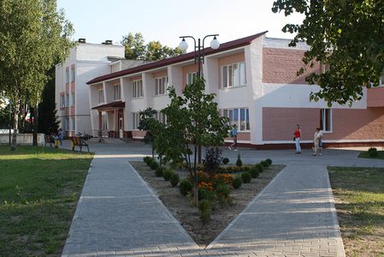
1. | Name of the project | "Healthy children are the future of Belarus"
2. | Name of company | Health care institution "Petrikov Central District Hospital"
3. | Physical and legal address of the organization, phone, fax, e-mail | Republic of Belarus Gomel region Petrikovsky district Petrikov st. Lunacharsky, 5  phone + 37523502-82-08  Email address : petrikov.gomel-region.by  petrtmo@mail.gomel.by
4. | Organization information | UZ "Petrikovskaya CRH" traces its history since 1914.  The first mention of medical institutions on the territory of Petrikovshchina dates back to 1914. Since 1919, in the town of Petrikov, there was a Soviet hospital, which was located in the building of a former military warehouse, which included 3 buildings. The hospital was designed for 30 beds. The hospital employed 3 doctors, 2 paramedics, 22 technical personnel, the head of the Soviet hospital was Mikhail Adamovich Rutkovsky. Today, the hospital has become the center of a wide network of medical and preventive institutions in the region, district hospitals, outpatient clinics and feldsher-obstetric centers are operating, specialized types of medical care are being developed
5. | Head of the organization | O. L. Semikopenko, chief physician, "Petrikovskaya CRH"  +37523502-82-08
6. | Project manager | O. L. Semikopenko, chief physician, "Petrikovskaya CRH"  +37523502-82-08
7. | Previous aid received from other foreign sources | The health care institution "Petrikovskaya CRH" did not receive any assistance from other foreign sources.
8. | Amount required | 4500.00 ( US dollars )
9. | Co-financing | All sponsor funds
10. | Project term | 2020-2021 year
11. | Objective of the project | -creation of a children's playground for children, as well as children with disabilities, on the territory of a health care institution, to alleviate the physical and moral condition of the child at the time of his being on treatment  - a playground is necessary for children to return to a healthy life. Doctors of the children's department carry out everything, both therapeutic and rehabilitation measures that can be carried out indoors, but the child needs to be distracted from the burden of treatment, and games in the fresh air are very necessary, for which a playground is required.
12. | Project objectives | - collection of funds for the construction of a children's playground on the territory of a health care institution, intended for games of children undergoing treatment. - the playground must be safe and free from injuries
13. | A detailed description of the activities within the project in accordance with the assigned tasks | -Choose and justify a place for a playground;  -Preparation of the territory for the placement of the playground  -Equipment installation  Target group: children from one year of age  Responsible person: O. L. Semikopenko, chief physician of the Petrikovskaya CRH
14. | Justification of the project | - installation of a modern integrated playground;  - creation of barrier-free access to the playground for children with disabilities;  - The playground should be aimed at the mental and physical development of children in an active playful manner.  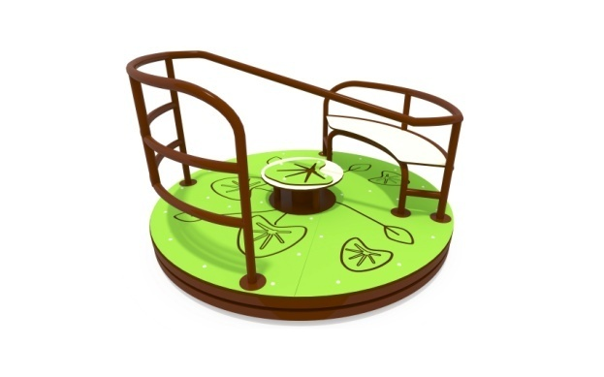  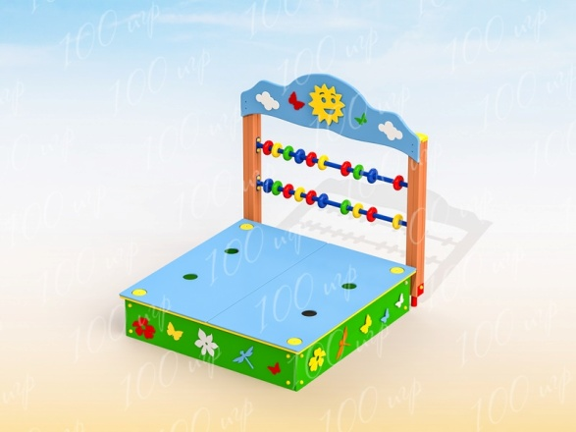  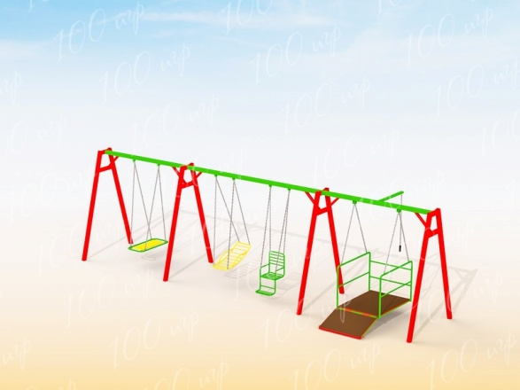
15. | Post-project activities | After the end of the project, the children will be able to go out into the fresh air and be distracted from the hardships of treatment.
16. | Project's budget | 4500,00 ( US dollars )

